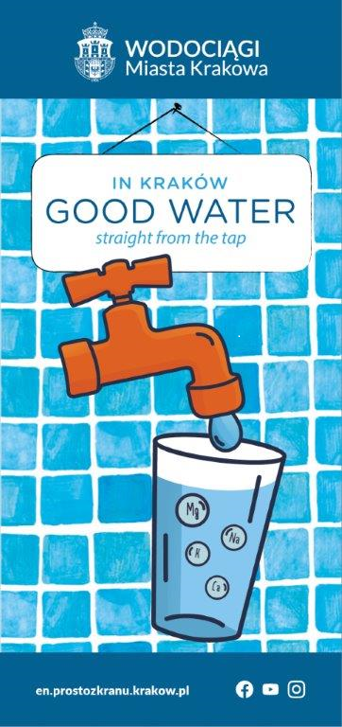
Alternative description to graphic: At the top the logo of Krakow Water, below a plate with the inscription in Krakow good water straight from the tap, below an orange tap and a glass of water. In the water symbols: Mg, K, Ca, Na. At the bottom left the website address en.prostozkranu.krakow.pl, on the right logotypes: Facebook, YouTube, Instagram.

IN KRAKÓW GOOD WATER STRAIGHT FROM THE TAP

TURN THE TAP ON AND TAP WATER FLOWS!
Before it reaches the taps in our homes, it has to undergo a multi-step treatment process.
Diagram of water treatment presented by graphic with a line of pipes, based on example of the Raba Water Treatment Plant. Water drawn from 4 rivers: Raba, Rudawa, Sanka, Dłubnia, goes through consecutive processes:
- OZONE TREAMENT
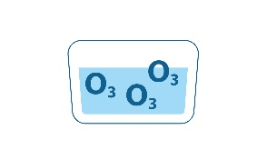
- COAGUALTION
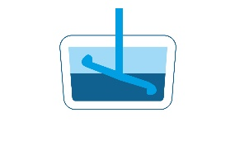
- SEDIMENTATION
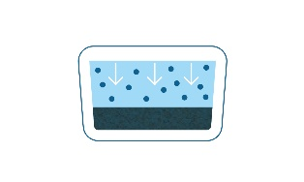
- FILTRATION
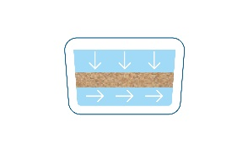
- UV DISINFECTION
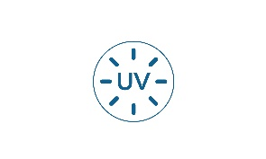
- DISINFECTION WITH SODIUM HYPOCHLORITE

SAFETY
- a modern laboratory
- 110 thousand analyses per year
- controlling 140 physical, chemical and bacteriological indicators in drinking water

MINERALS
Tap water contains magnesium, calcium, potassium and sodium, which are minerals necessary for the proper functioning of the human body. They are called „the elements of life” and are best absorbed from water!
Average mineral content [mg/l]:
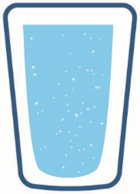650 mg/l medium mineralised water
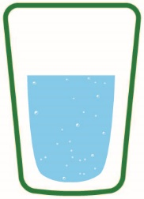365 mg/l tap water
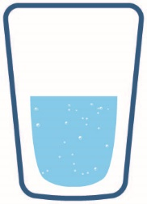322 mg/l low mineralised water
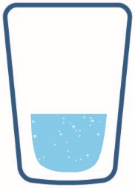18 mg/l spring water

HARD OR SOFT?
Water hardness depends on its mineral content. Boiling water causes some of the minerals to precipitate and form scales. This softens the water but also impoverishes its mineral composition.

WATER IN US
Human body does not store water, so it is important to replenish it regularly.
- 60-70% is the percentage of water in the total body weight of an adult person
- 2-2,5 l is the amount of water an adult person should drink every day
- 10% loss of water can disturb the proper functioning of the body
- 20% loss of water in the body may cause death

AWARENESS
Tested and treated tap water is safe and healthy!
It meets Polish and European quality requirements.

SAVINGS
Drinking tap water is cost-effective, environmentally friendly and convenient!
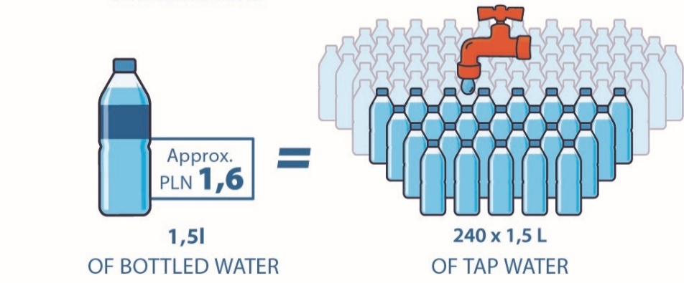
Alternative description.to graphic: on the left a plastic bottle with a description: 1,5 l bottled water, approximately 1,6 zł. Equal sign in the middle of the graphic. On the right many plastic bottles. Above them a tap suggesting that the bottles are filled with tap water. Below the bottles a description: 240 multiplied by 1,5 L of tap water.

ENVIRONMENT
Plastic waste ending up in oceans kills over a million sea birds and a hundred thousand mammals every year.

GOOD PRACTICES
- take a quick shower instead of a bath
- run the dishwasher/washing machine only when it is full
- use water-saving toilet flushes
- turn the tap off while brushing your teeth

HOW MUCH WATER DO WE USE?
- 60 - 80 l a day – washing the dishes
- 30 - 50 l a day – flushing the toilet
- 80 - 100 l a day – washing machine
- 2,5 - 3 l a day – drinking
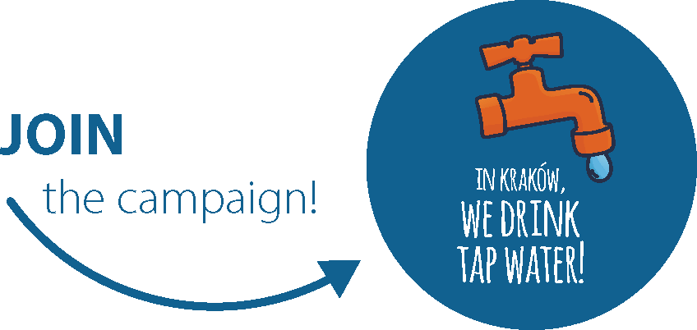
DID YOU KNOW THAT... every year more and more residents of Krakow drink tap water ? Join us, because drinking tap water is good, cost-effective and environmentally-friendly!

TAP WATER IN URBAN SPACES:
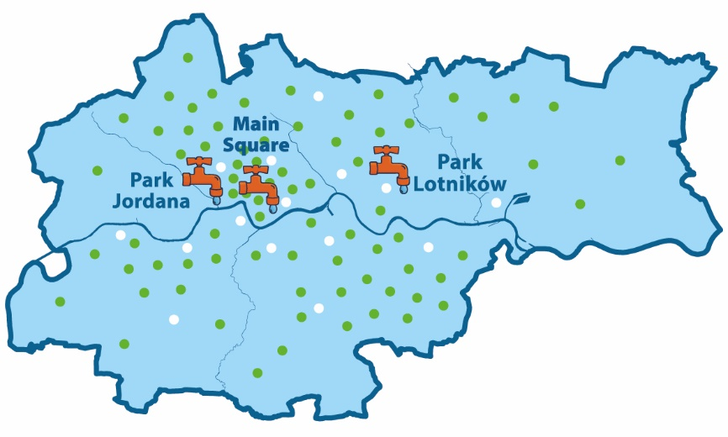
Alternative description. An outline map of Krakow, covered mostly with green dots and a few white dots. Inside three orange taps: Jordan Park, Main Square, Park Lotników.
A map key:
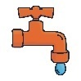outdoor DRINKING FOUNTAINS
School DRINKING FOUNTAINS
DRINKING FOUNTAINS at public offices and hospitals
Wodociągi Miasta Krakowa S.A. ©
ul. Senatorska 1, 30-106 Krakow, Poland
+48 12 42-42-300, biuro@wodociagi.krakow.pl
en.wodociagi.krakow.pl
BDO: 000007387

